

Orbital Project – Gemini

[Project ReadMe and Log]

By

**TEAM 1216**

LIM ZHENG DE A0144015W

LEROY TANG ZHENG XI A0139499H

**Content Page**

1. Readme
   1. overview
   2. Ignition slide
   3. Sound cloud link for our ignition slide
2. Ideation
   1. Evaluation of milestone 1
   2. Evaluation of milestone 2
   3. Evaluation of milestone 3
3. Planned Features
4. Proposed Level of Achievement
5. References used
6. User stories
7. Project Log
8. Conclusion

**README:**

**1.1 OVERVIEW**

NUS-Facilities is a web platform for the students and staffs in NUS to check on the occupancy of the facilities located in the school. The staff, students and alumni who wish to use certain facilities like the library or gym would be able to check up on the free space available before making the decision if they would still wish to use said facilities.

The problem we have observed in the university in general would be the overcrowding of certain areas especially during certain periods of the year. One period would be about 4 weeks to the final examinations. During this period, the central library would get more packed than usual. This leads to many students having made the trip to central library planning to conduct research or study being unable to find a seat due to overcrowding. This observation can also be seen in the education resource centre in U Town. Another observation we have made is that the gyms would be really crowded on weekday nights. The problem that this bring about would be that gym users would be unable to complete their workout or spend much more time than intended in the gym than they would like.

Hence, our web platform would help anyone in NUS looking to use such facilities make a better decision and plan out their day which would save them the most amount of time. Hence, we are currently aiming our project to be Gemini level.

**1.2 Ignition Slide**

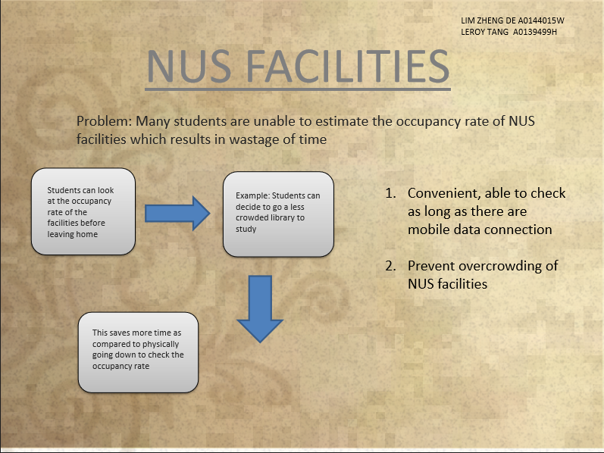

**1.3 Link for Ignition slide**

Sound cloud link:

<https://soundcloud.com/lim-zhengde/team-1216-orbital>

**2.1 Ideation of Milestone 1**

* We have come up with the language to learn to create a webapp : HTML, CSS and Javascript

**7. Project Log**

Currently, we have just recapped finished our C language as we have both forgotten a little about the syntax for programming. We are also looking into the different languages for developing web application and deciding which one is best suited for our project. We have fulfilled 15-20% (20 hours) of the requirement of at least 130 hours for this orbital project. Hopefully we are able to come up with a simple webpage within the next 2 weeks with the new coding language that we learned. Furthermore, we will be heading down to school to understand how the tap card system for NUS gym and libraries work so that we can better incorporate it into our project. – **Iteration phase 1**

Link to our project link:

<https://docs.google.com/document/d/1HDugpXhiqWjgCatMLZu-uNjqlf-ODoAB_e2xGRcOcxs/edit>